Analysis/evidence on the impact of the Danish exemptions
to European Seed Legislation

DK Seed Legislation in short
Seed marketing and seed exchange of unregistered varieties is permitted as long as the seeds are not for commercial use. Commercial use is understood as marketing of seeds for agricultural and horticultural production.
The rules apply to sales and exchanges without payment as well. The only thing that matters is if the person or company who receives the seeds will use them commercially. This also means that companies (e.g. professional farmers, gardeners, and seed companies) can sell unregistered varieties legally to private persons but not to other farmers or professional gardeners. It applies to all seeds not intended for commercial exploitation. There is no limitation to the amounts.

Do we in Denmark have any analysis/evidence on the impact of DK-exemptions:
- on the quality of seeds for hobby gardeners
The most straightforward argument is that the Danish Ministry of Food was behind the exemptions - and still is.
- They gave out a report with guidance to the Danish interpretation of the EU seed Legislation in 2015. The Danish Seed Savers translated it into English in 2018, and you can read it here.
- In April 2022 the Ministry made an updated version - not different in what is described above about the way the rules are interpreted. The Danish Seed Savers were - among others - asked to peer review it. Read it here.
- There is a small brochure from the Ministry explaining the rules of exchanging seeds: “Exchange seeds and strengthen biodiversity”.
- They also made this flow-chart, that makes it easy to understand if you can exchange or sell seeds:
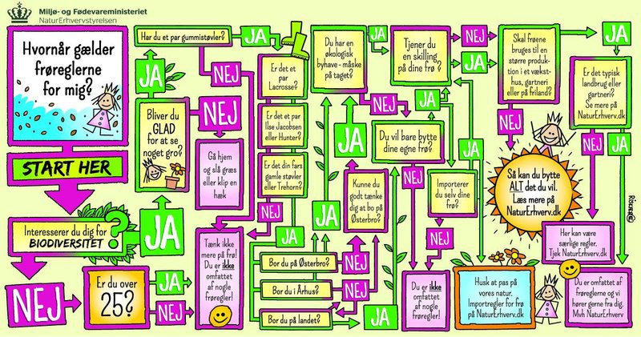
(You can find an English version of this flow-chart on page 8 in the publication “Legal Aspects of Seed Marketing and Exchange in the Baltic States and Denmark From a Seed Saver’s Point of View”, written by the Danish, Estonian, Latvian, and Lithuanian Seed Savers).
That the Danish Ministry of Food is behind the exemptions only tells that there have been no catastrophes concerning the quality of seeds sold to or exchanged among hobby gardeners. If this had been the case, the Ministry would have been forced to change it.
We find no research or other evidence to prove the quality of seeds from hobby gardeners.
- the diversity of varieties available in the market for hobby gardeners
The Danish exemptions have resulted in many varieties available for hobby gardeners. The following actors exchange or sell conservation varieties or new, specially bred varieties:
All 456 varieties preserved by the Danish Seed Savers can now be exchanged among the 1200 members, and furthermore 150 are sold to the public on markets and 27 varieties in the web shop.
Fuglebjerggaard sells 1626 varieties, of which 600 are described as old varieties (we are not sure how many are unregistered varieties, but many of them are).
Landsorten sells 57 varieties, mainly grains.
There might be more varieties available, but we think that these are the main sources.
A little more about the Danish Seed Savers and distributing diversity
The Danish Seed Savers participate in 40 to 50 markets per year, and this means more than 1000 seed packets sold. A similar amount of seed packets are sold through the web shop.
All seeds are donated by the members from their home gardens or small farms, all open pollinated and non-listed varieties of landraces, heirlooms and ex-commercial varieties.
At the markets, we communicate with people. We underscore the importance of preserving these varieties and increasing access to diversity through conversations, publications and historical information in the seed packets.
Other seeds sold on the web
All non-commercial sale and exchange of seed is based on confidence. Seed is offered on the web, where the origin, identity, source or production method is not clear. So, a negative effect of the liberal seed legislation is the lower traceability, making it unclear whether the seeds you buy as a hobby gardener are clean, healthy and able to germinate.
We may encourage actors that sell seed on this non-commercial market to inform adequately on these parameters to avoid misunderstanding, confusion and cheating.
- the range of actors selling seeds to hobby gardeners – for example are there any new companies / associations / farmers selling seeds, now that it is easier?
- the Danish Seed Savers
- Landsorten
- Fuglebjerggaard
- Copenhagen Seeds (not active)
- TagTomat (small amounts)
- Frøspiren (small amounts)

Copenhagen Seeds, Landsorten, and the Danish Seed Savers’ web shop are examples of actors having started their selling of seeds as a result of the Danish exemptions from the EU Seed Legislation in 2015. All experience a large interest from consumers, have had good experiences, and sell many seeds (Copenhagen Seeds is inactive due to other reasons). The Danish Seed Savers’ selling on markets has been an activity also before 2015, and gone ‘under the radar’ with the Ministry.
There might be farmers or other smaller companies selling unregistered seeds on the web, but we don’t find any. They might also sell seeds directly from the farm, but this has not been possible for us to find, either.
We have searched the web, and we find a lot of smaller actors selling seeds, e.g.:
Bland Selv Frø, Fantastiske Frø, FrøTorvet, ØkologiskeFrø.dk, Bjarnes Frø og Planter, Kridtvejs Planter, Haveisten.dk, No1
The seeds they sell seem to be seeds registered in Denmark or in another EU country. So, these are not interesting for the Danish exemptions.

